Sri Lanka Institute of Information Technology



Bachelor of Science (Hons) in Information Technology Specialized in Information Technology

Modern Topics in IT – (IT4020)

OSGi Assignment Marking Rubric Assignment 01 Report -2022

Submitted By:

IT18220834 - Wijethilaka R.G.K.H

IT18212150 - Balasooriya T.D

IT18212600 - Perera C.A.R.P

IT18219944 - Hashan P.G.B

Group ID: MTIT-034

Submitted To:

20th March 2022

Individual Work Allocation

|  |  |  |
| --- | --- | --- |
| Student Name | IT Number | Work Allocation |
| IT18220834 | Wijethilaka R.G.K.H | **Cashier** – Manifest implementation, all commands run with OSGI framework (Publisher and Subscriber) |
| IT18220834 | Balasooriya T.D | **Lecturer** – Manifest implementation, all commands run with OSGI framework (Publisher and Subscriber) |
| IT18212600 | Perera C.A.R.P | **Undergraduate** - Manifest implementation, all commands run with OSGI framework (Publisher and Subscriber) |
| IT18219944 | Hashan P.G.B | **Course** – Manifest implementation, all commands run with OSGI framework (Publisher and Subscriber) |

Contents

1. Explain the Scenario using a diagram 3
   1. Component Diagram 3
   2. Activity Diagram 4
2. Manifest implementation 5
   1. Exported services. 5
   2. Imported services. 5
   3. Manifest implementation images 5
      1. Student Publisher 5
      2. Teacher Publisher 6
      3. Subject Publisher 6
      4. Assign Publisher 7
      5. Admin Subscriber 7
3. All commands of bundle install and run in OSGi framework. 8

1. Run project in eclipse. 8

1. Sample screenshots of its behavior & outputs. 9
   1. Main interface 9
   2. Student service interfaces 9
   3. Subject service interfaces 10
   4. Teacher service interfaces 11
   5. Assign service interfaces. 12

# Explain the Scenario using a diagram.

## Component Diagram

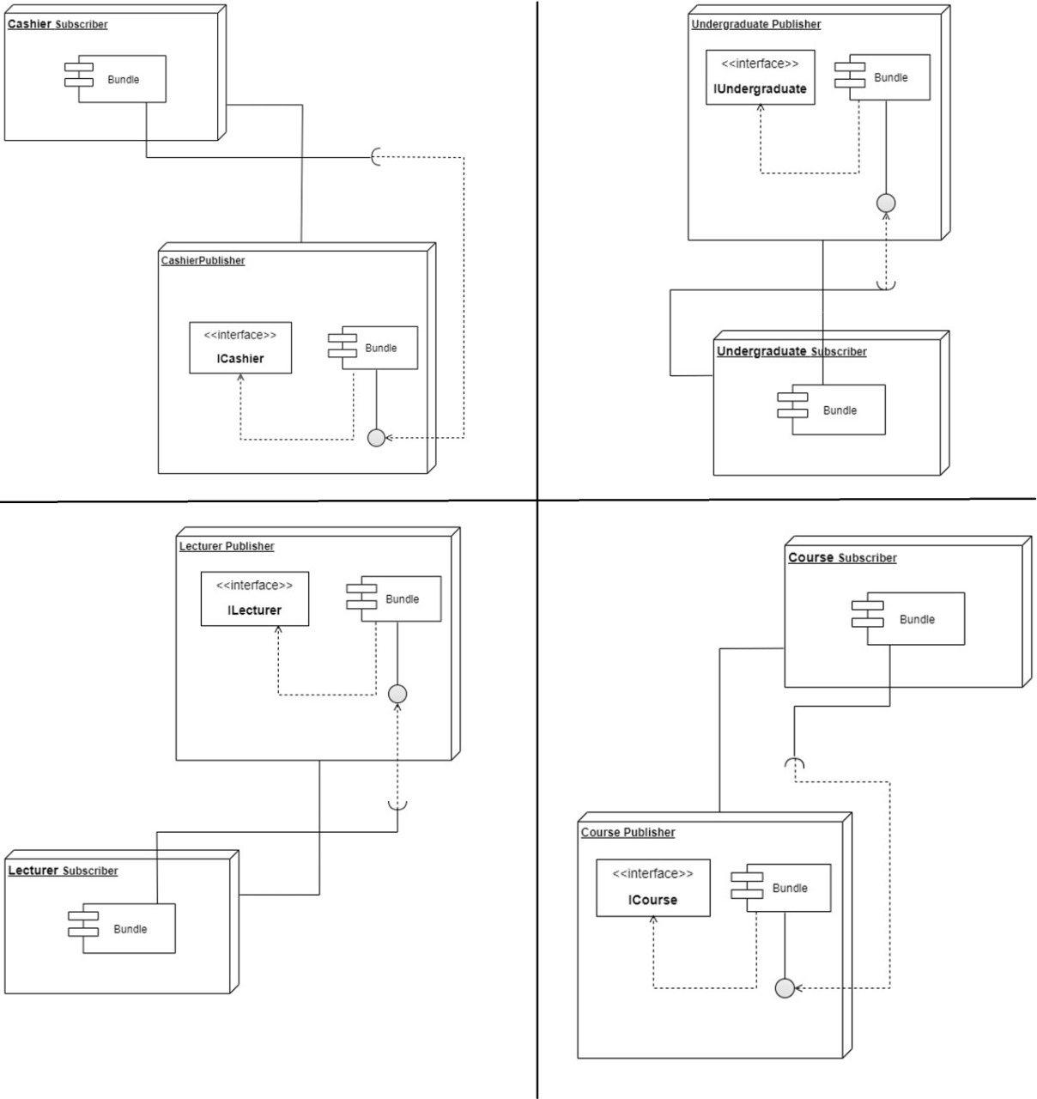

## Activity Diagram

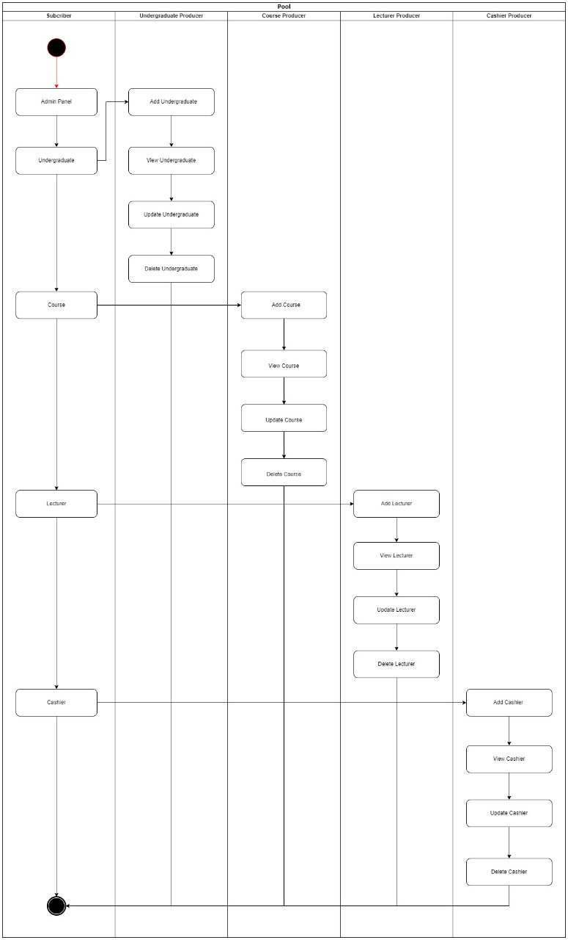

1. Manifest implementation

## Exported services.

* + - Undergraduate Publisher – undergraduatepublisher
    - Lecturer Publisher – lecturerpublisher
    - Course Publisher – coursepublisher
    - Cashier Publisher – cashierpublisher

## Imported services.

* + - Undergraduate Publisher – org.osgi.framework;version="1.3.0"
    - Lecturer Publisher – org.osgi.framework;version="1.3.0"
    - Course Publisher – org.osgi.framework;version="1.3.0"
    - Cashier Publisher – org.osgi.framework;version="1.3.0", undergraduatepublisher, coursepublisher
    - Undergraduate Subscriber - org.osgi.framework;version="1.3.0", undergraduatepublisher
    - Lecturer Subscriber - org.osgi.framework;version="1.3.0", lecturerpublisher
    - Course Subscriber - org.osgi.framework;version="1.3.0", coursepublisher
    - Cashier Subscriber - org.osgi.framework;version="1.3.0", cashierpublisher

## Manifest implementation images

### Undergraduate Publisher

### 

### Lecturer Publisher

### Course Publisher

### 

### Cashier Publisher

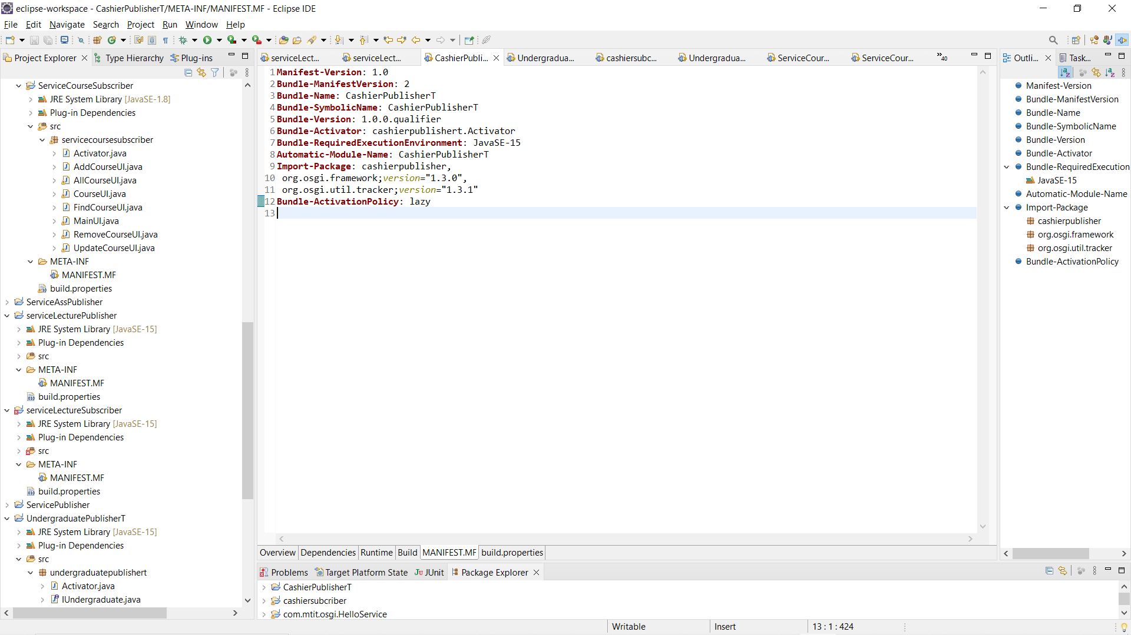

### Undergraduate Subscriber

### 

### Lecturer Subscriber

### 

### Course Subscriber

### 

### Cashier Subscriber

### 

1. All commands of bundle install and run in OSGi framework.
   1. Run project in eclipse.
      * Select publisher and right click -> Run As -> OSGi Framework.
      * After running all publishers then run the subscriber as mentioned above.
      * To see all running plugins their status and ids type “lb” on the console.
      * To stop running plugins type “stop <<plugin id>>”.
      * To start stopped plugins type “start <<plugin id>>”.

*Figure 1 Started Services.*

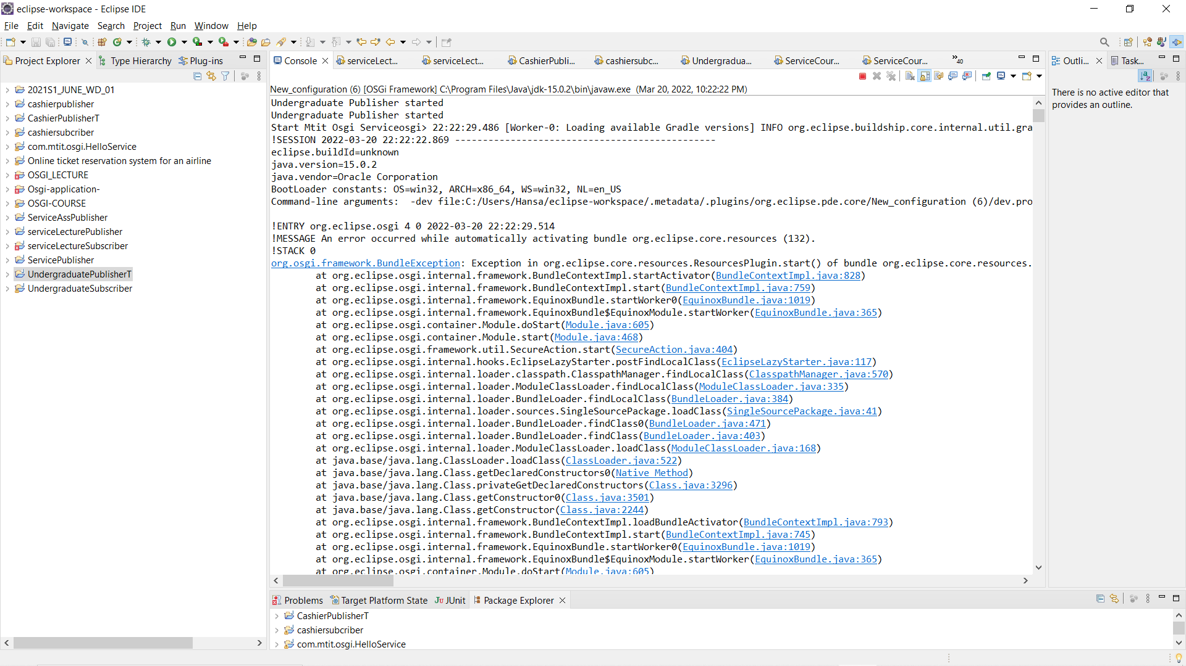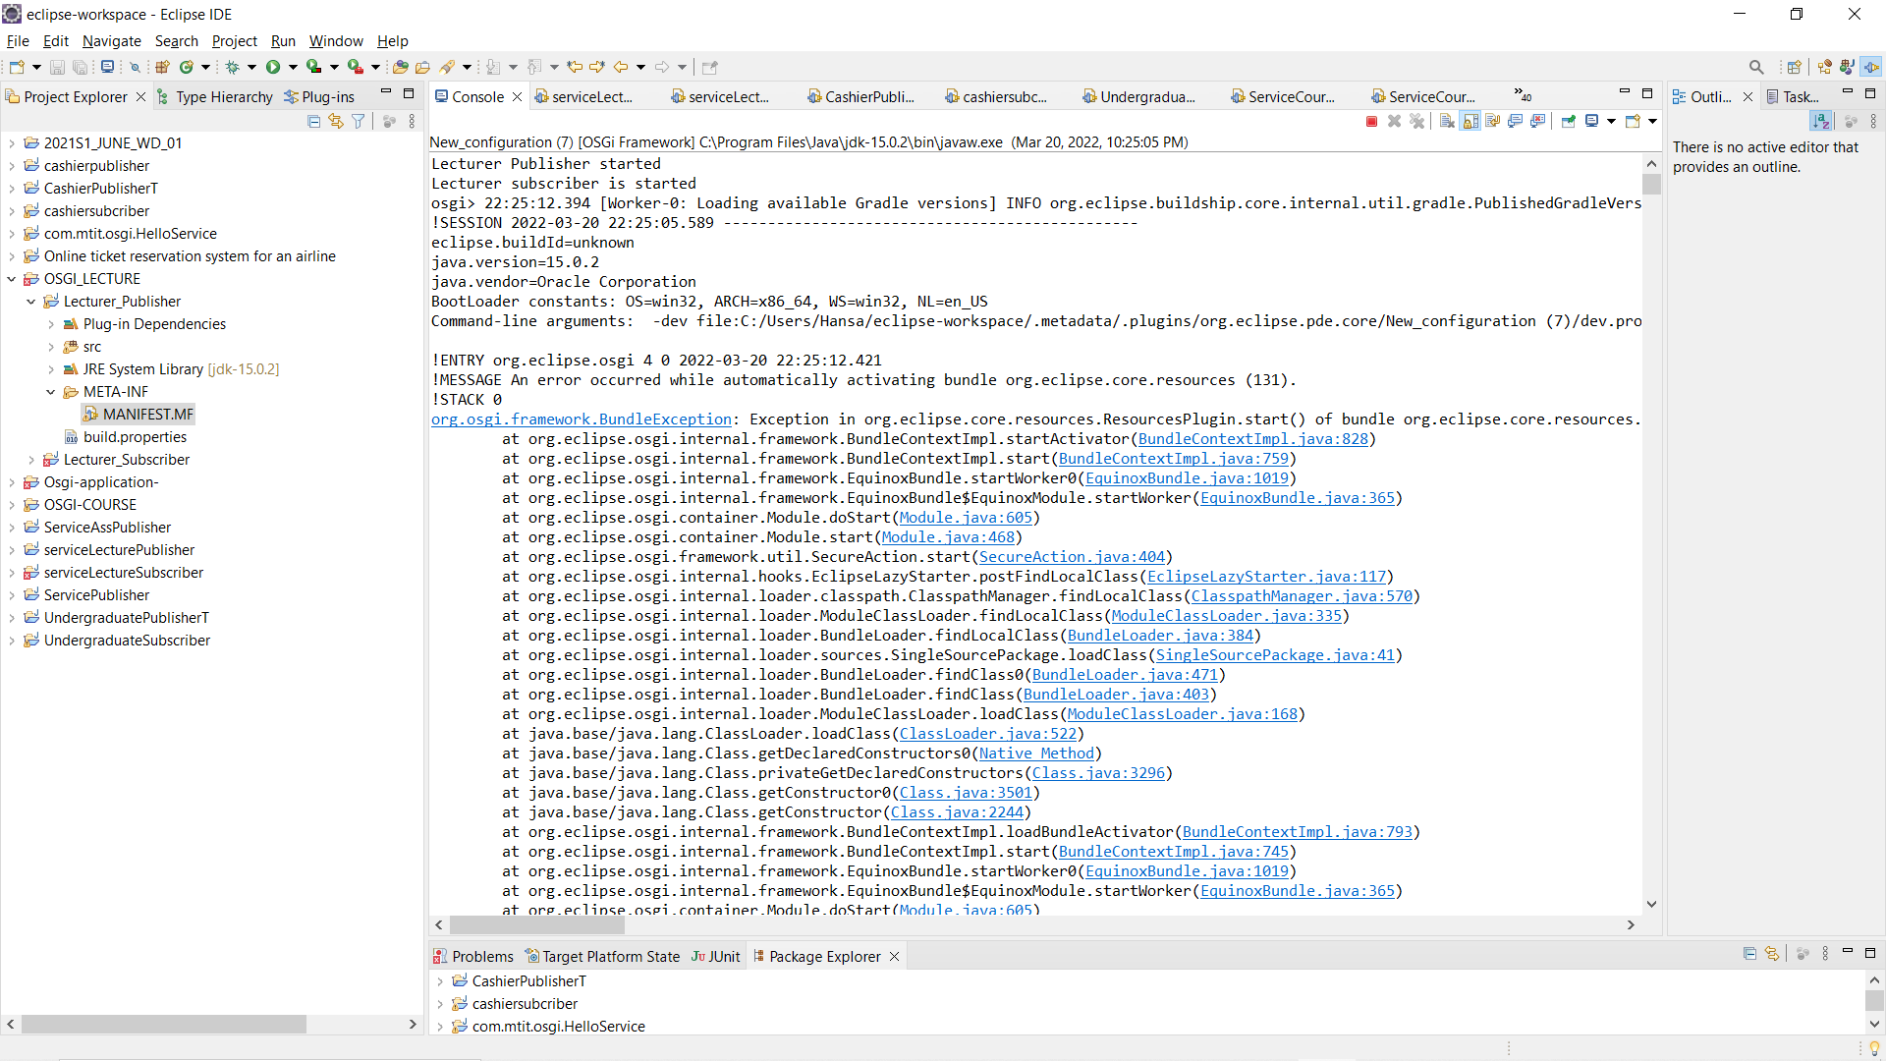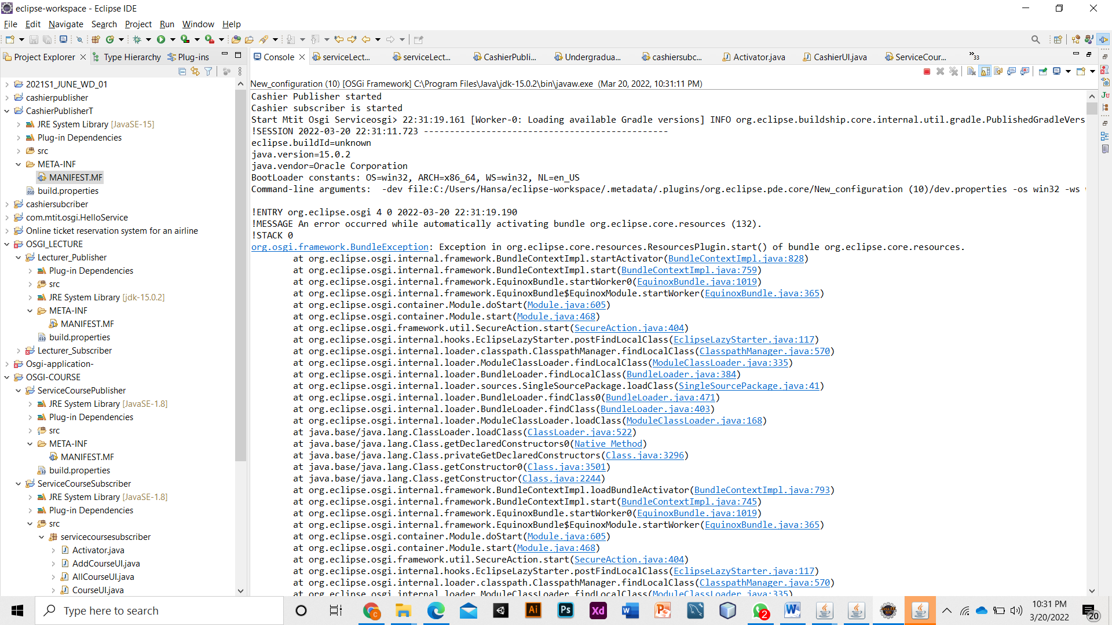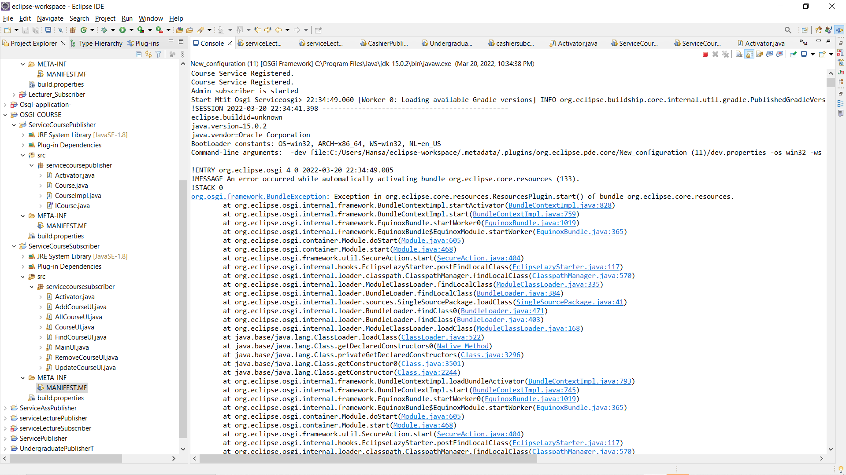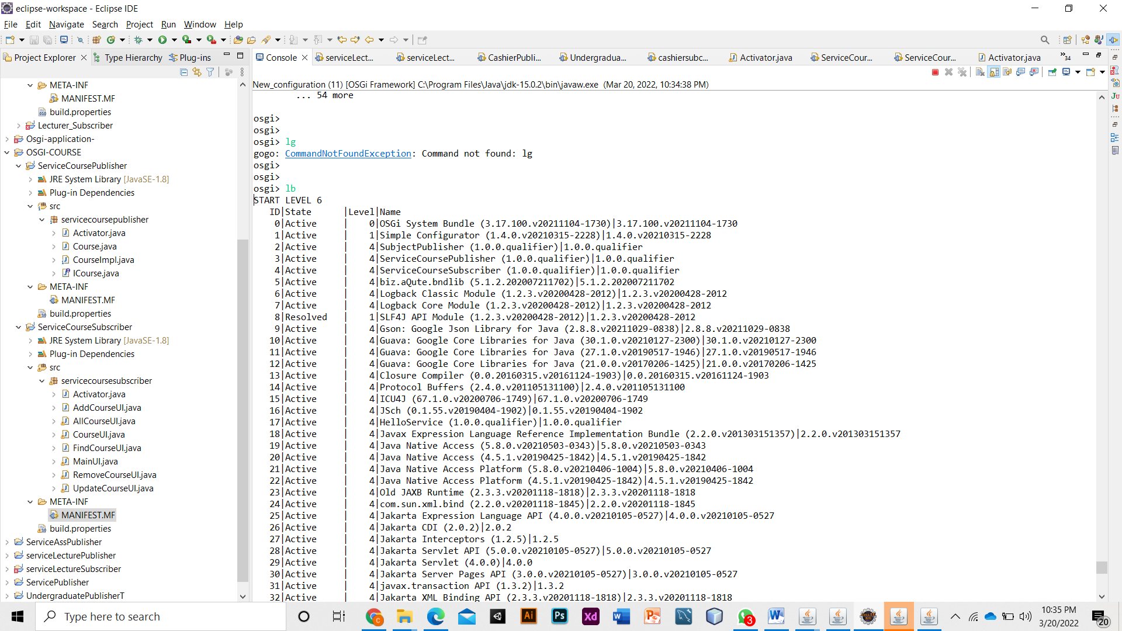

*Figure 1 Start Services.*

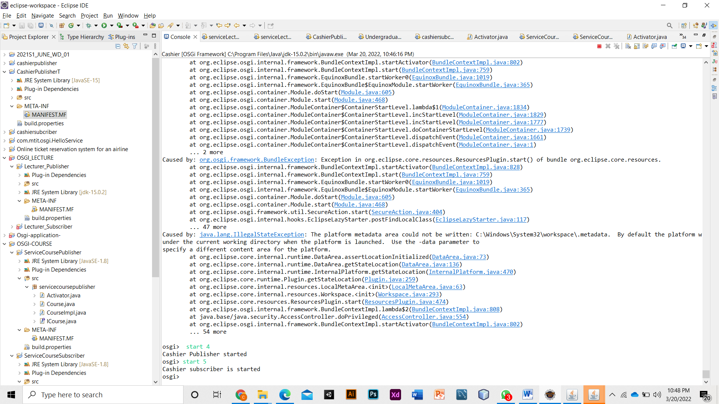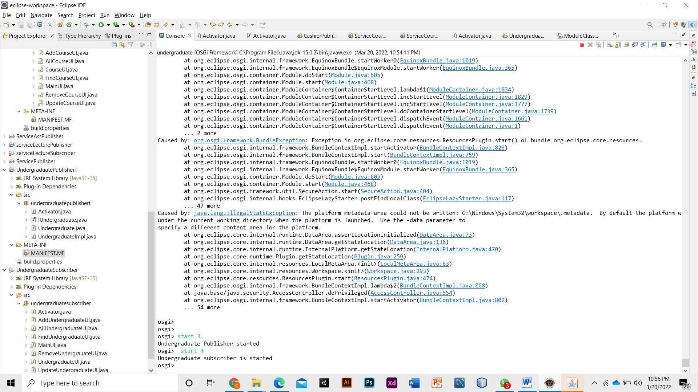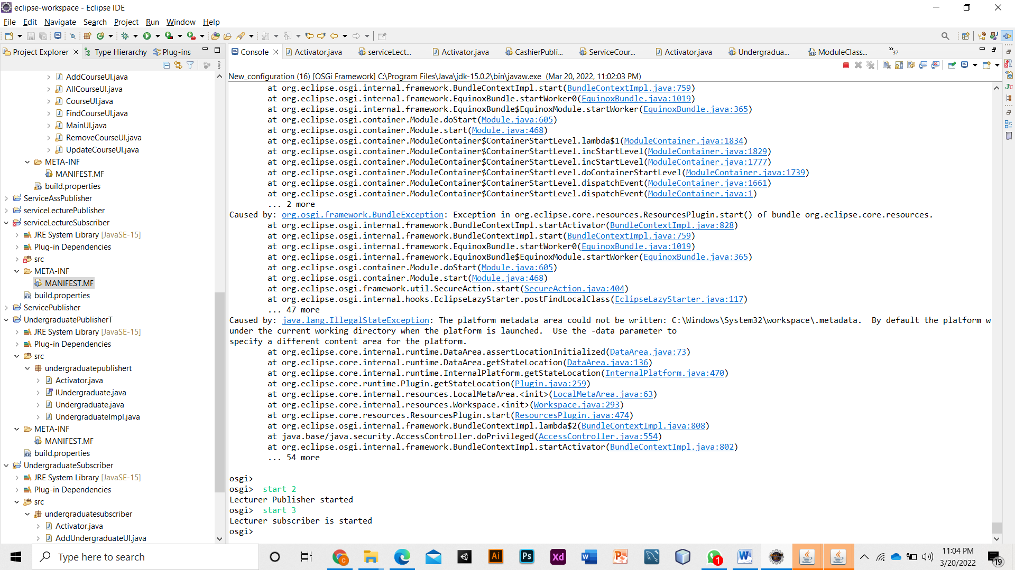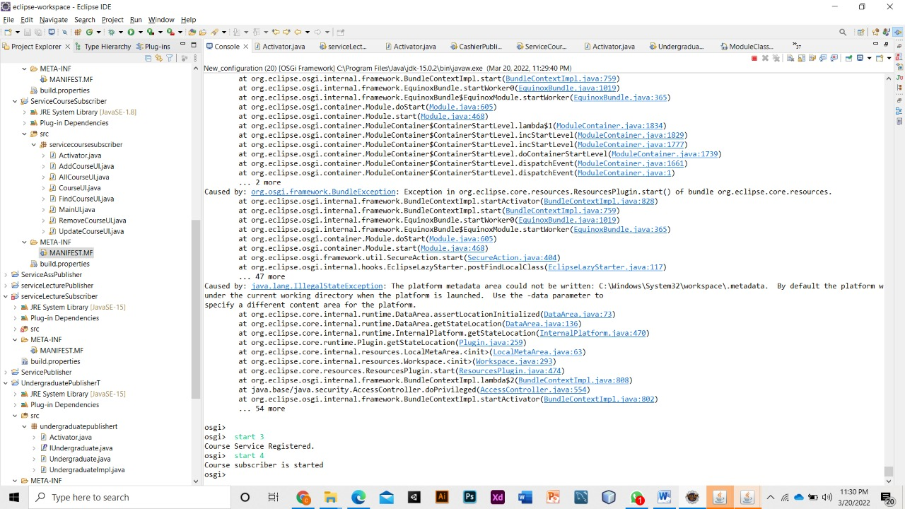

*Figure 3 Stop Services*

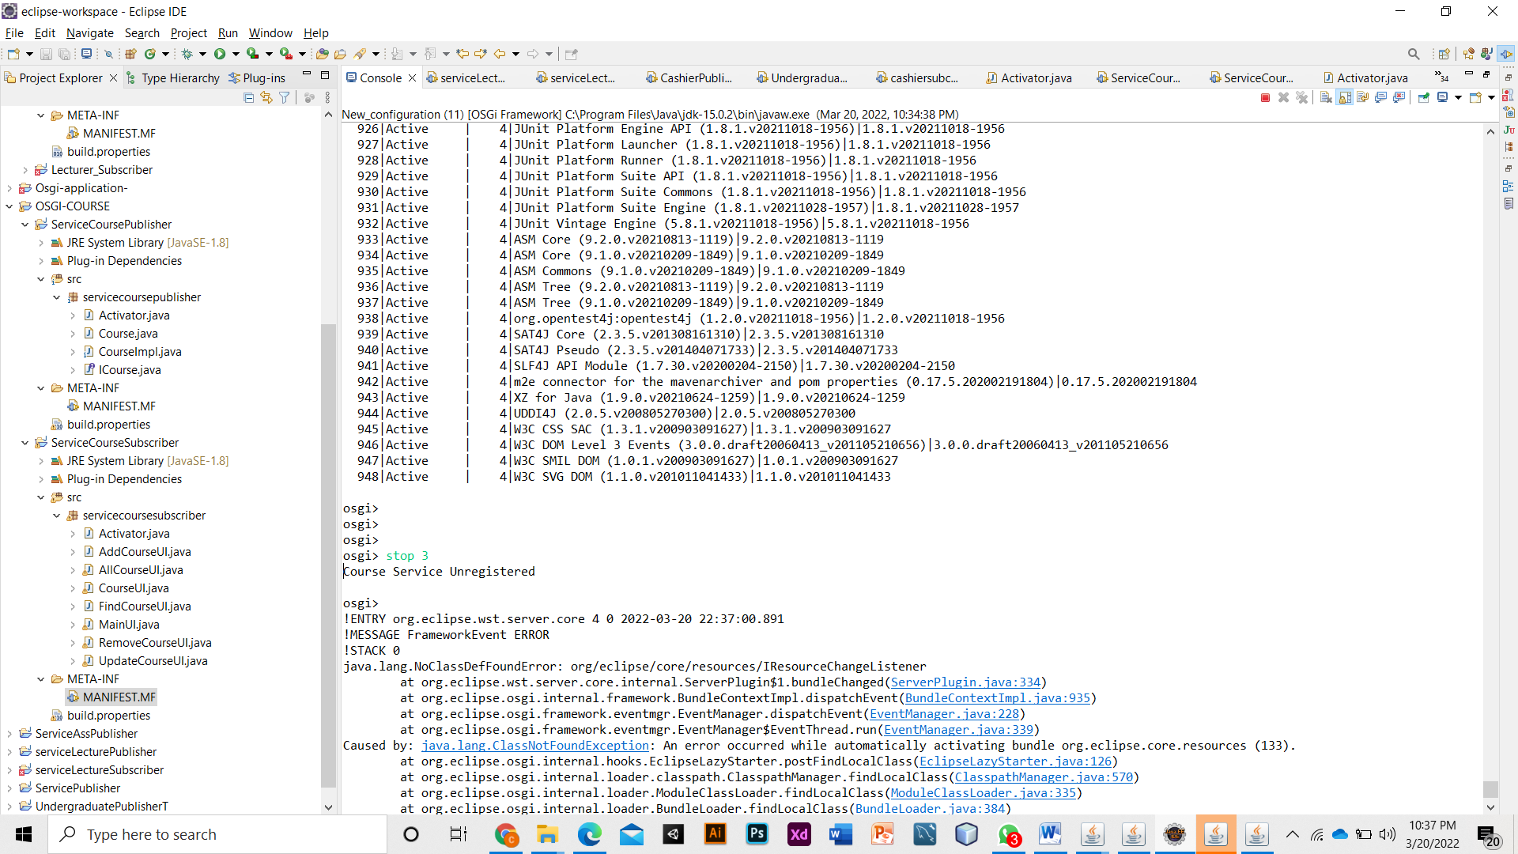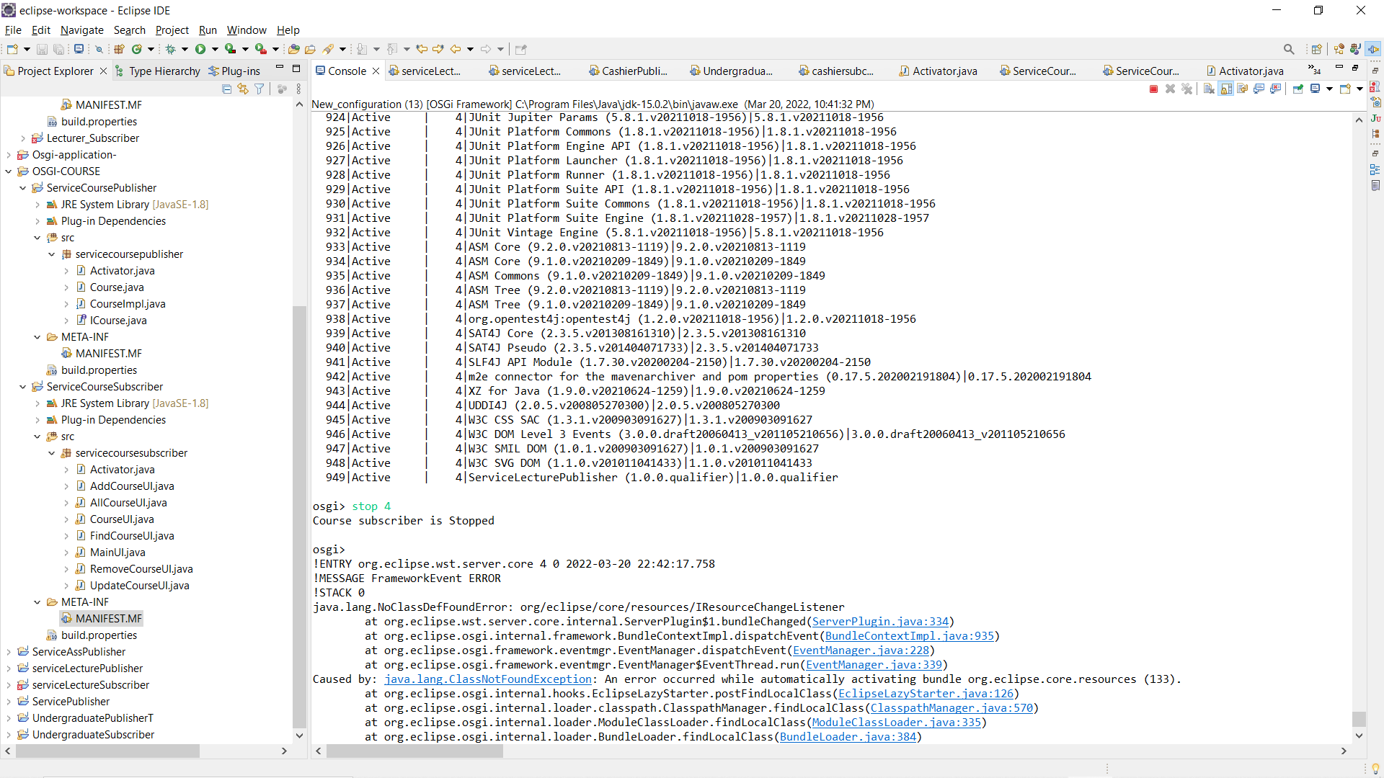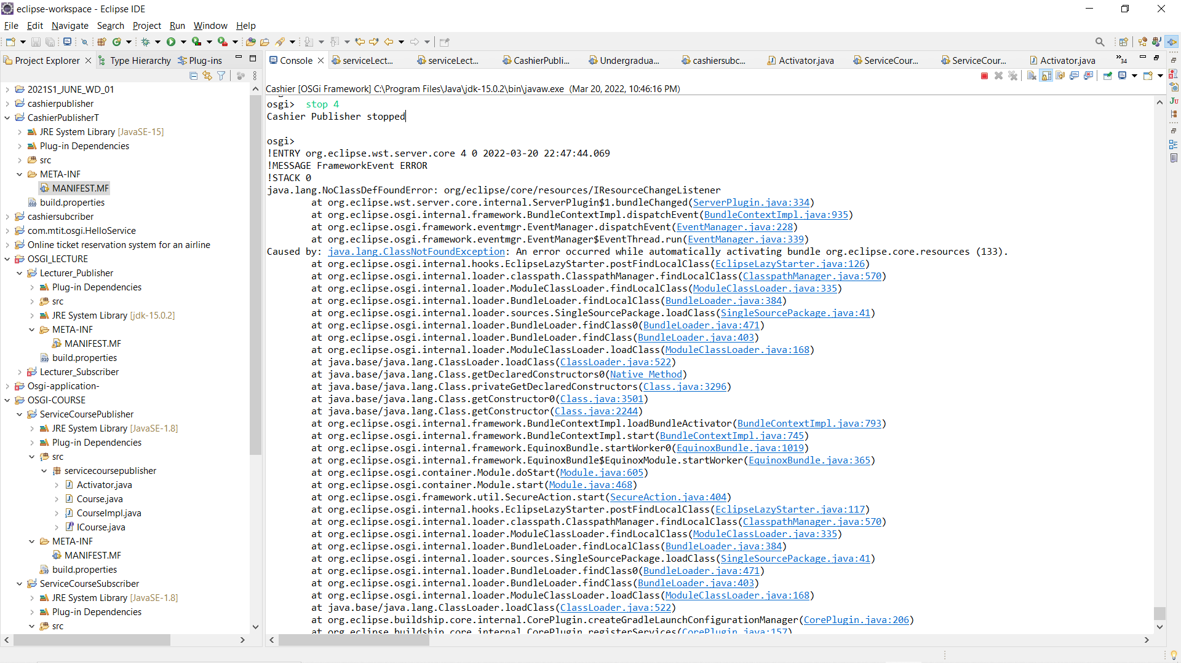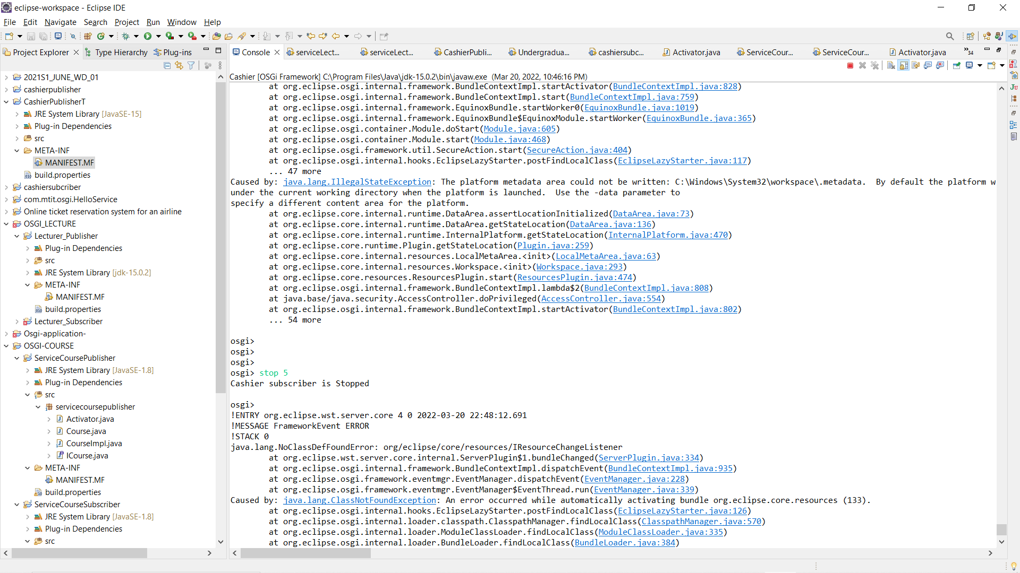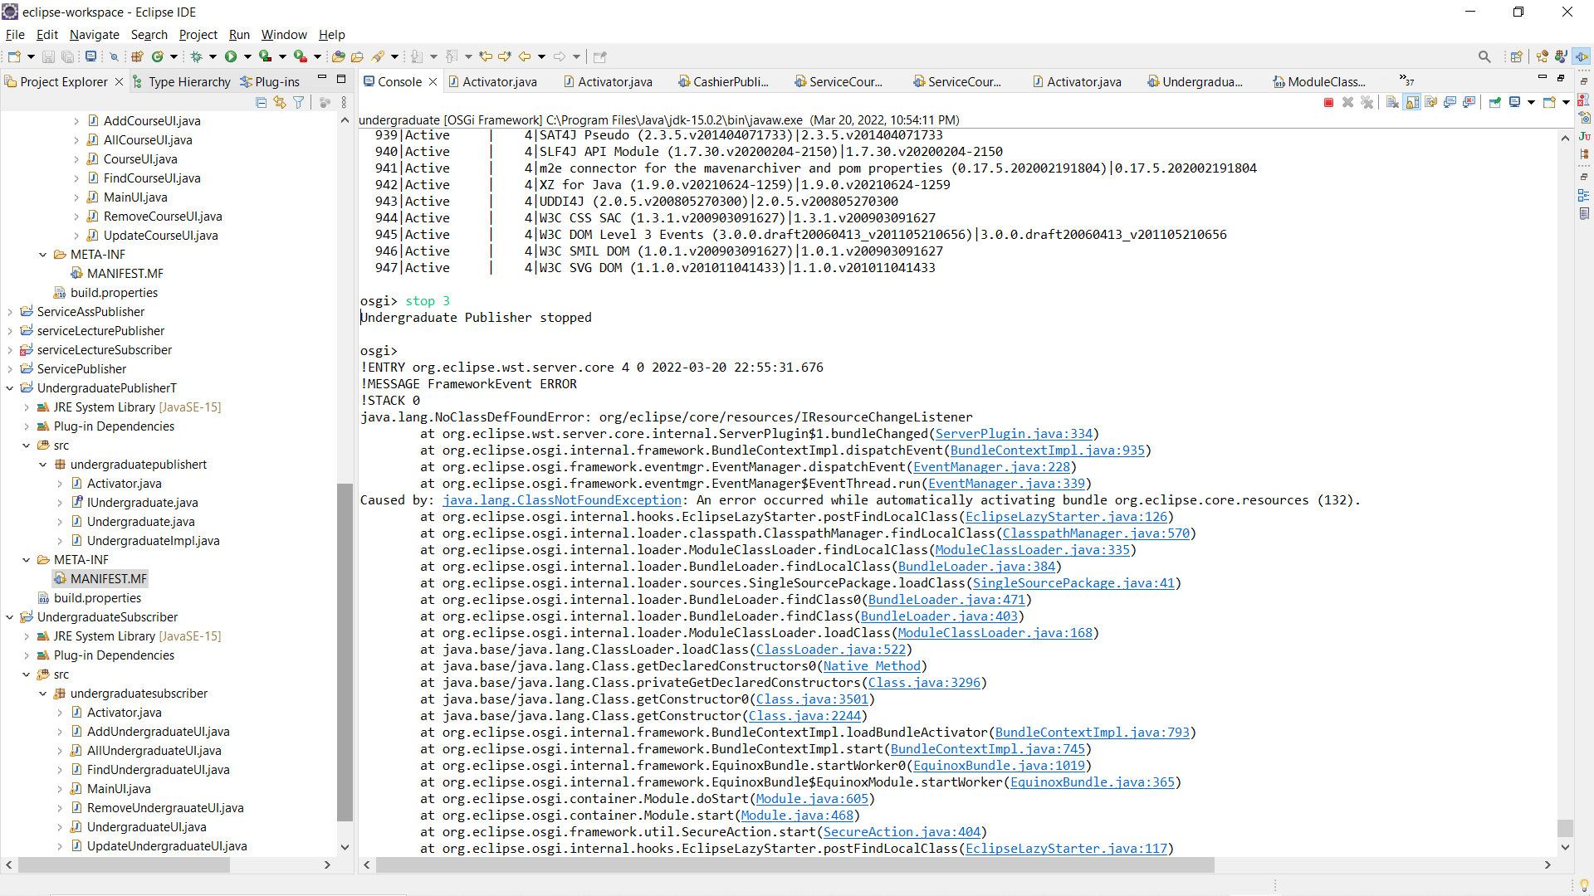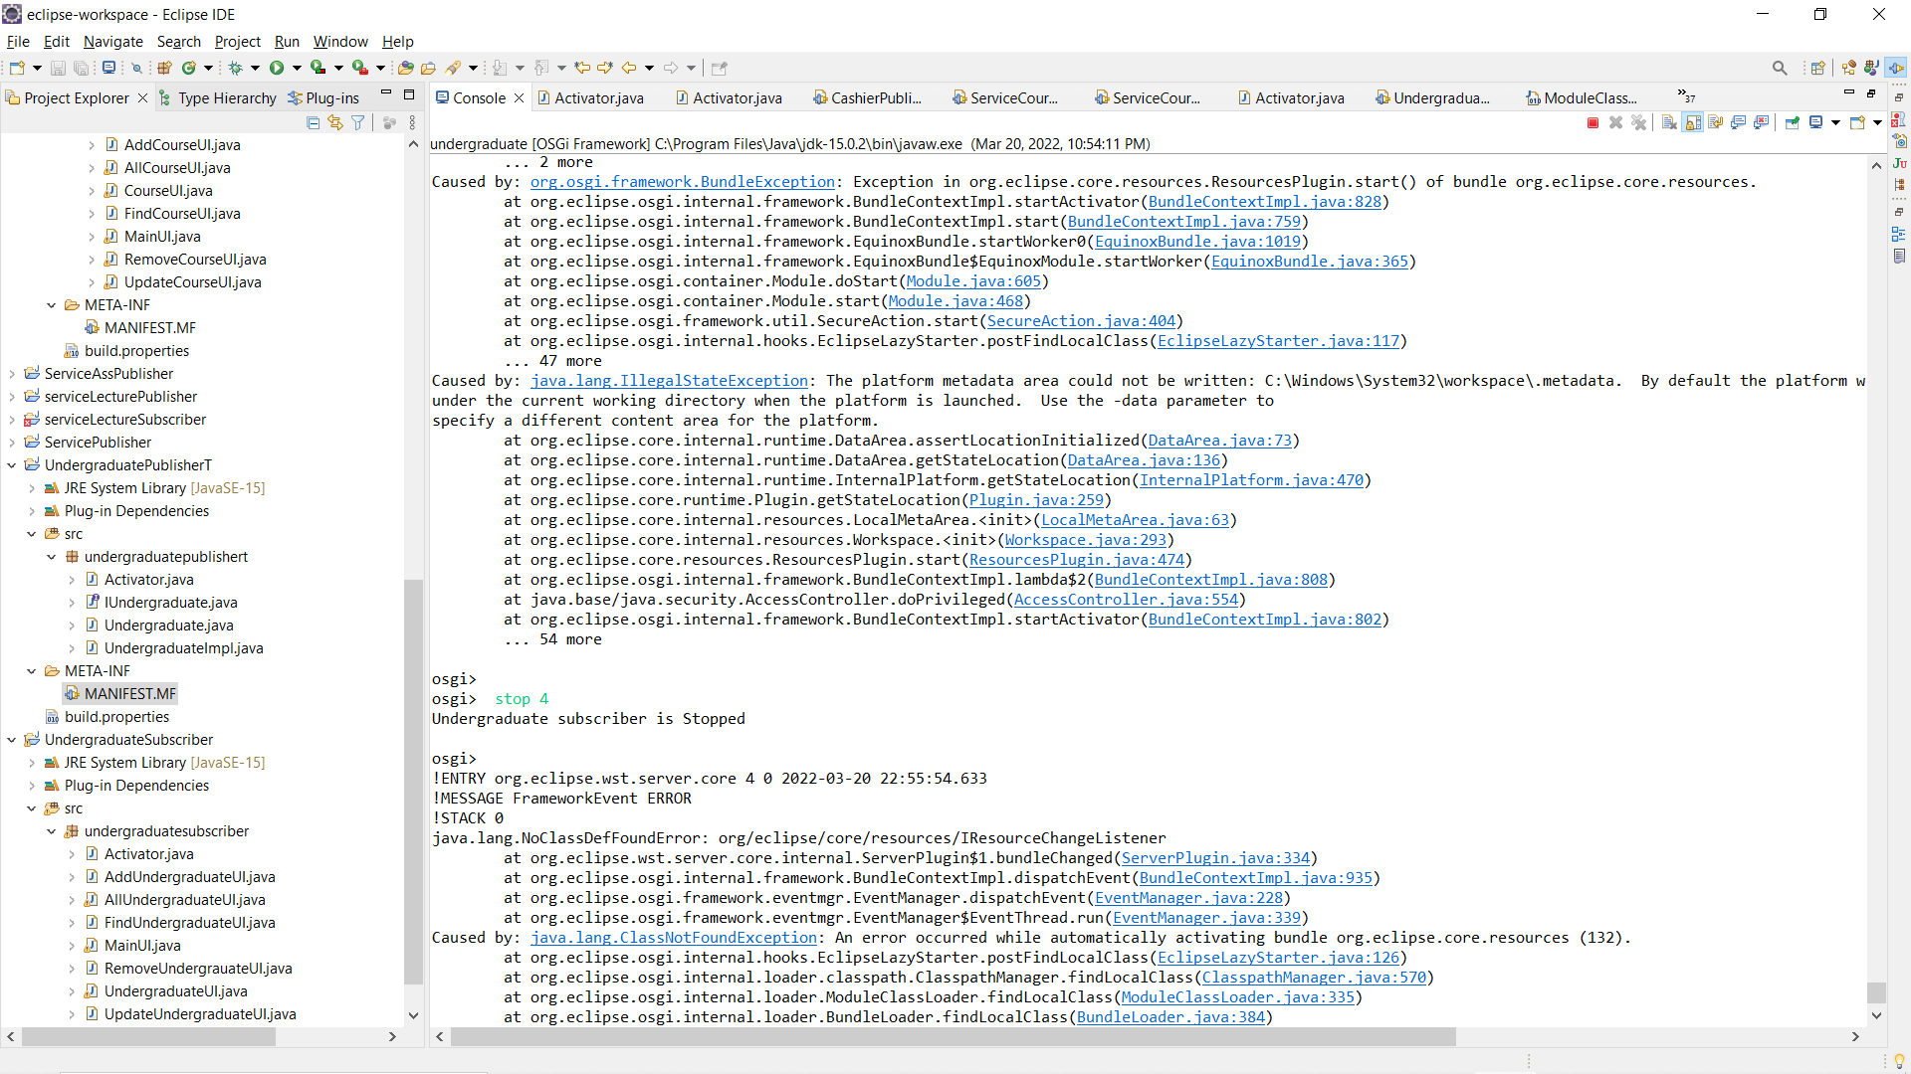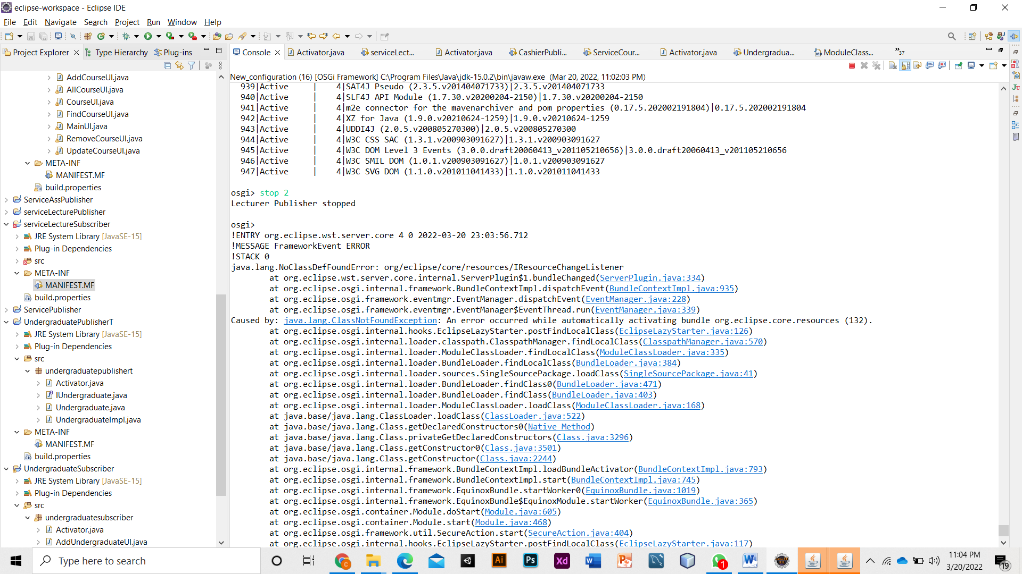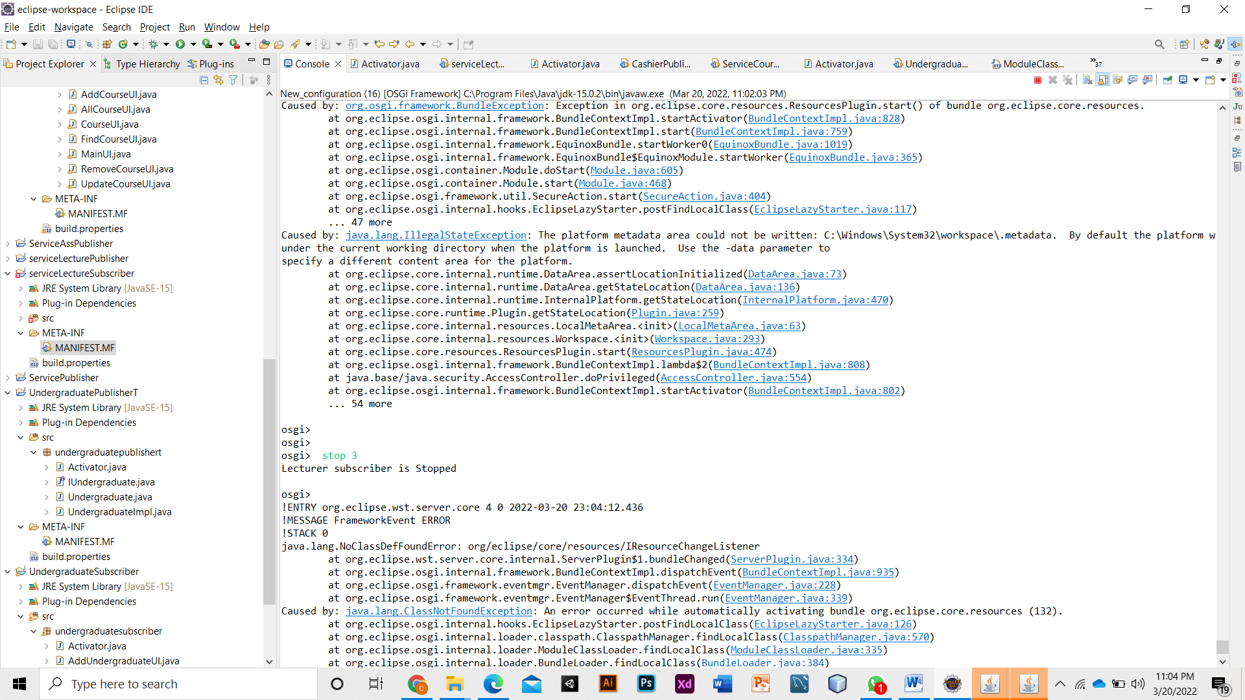

1. Sample screenshots of its behavior & outputs.

## Undergraduate service interfaces

|  |  |
| --- | --- |
|  |  |
| *Undergraduate: Add Undergraduate* | *Undergraduate: Confirm Undergraduate* |
|  |  |
| *Undergraduate: View Undergraduate* | *Undergraduate: Update Undergraduate* |
|  |  |
| *Undergraduate: Find Undergraduate* | *Undergraduate: Delete Undergraduate* |

## Course service interfaces

|  |  |
| --- | --- |
|  |  |
| *Course: Add Course* | *Course: Confirm Add Course* |
|  |  |
| *Course: View Course* | *Course: Update Course* |
| C:\Users\Hansa\Pictures\Screenshots\course find (2).png |  |
| *Course: : Find Course* | *Course: Delete Course* |

## Lecturer service interfaces

|  |  |
| --- | --- |
|  |  |
| *Lecturer: Add Lecturer* | *Lecturer: Confirm Add Lecturer* |
|  |  |
| *Lecturer: View Lecturer* | *Lecturer: Update Lecturer* |
|  |  |
| *Lecturer: Find Lecturer* | *Lecturer: Delete Lecturer* |

## Cashier service interfaces.

|  |  |
| --- | --- |
|  |  |
| *Cashier: Add Cashier* | *Cashier: Confirm Add Cashier* |
|  |  |
| *Cashier: View Cashier* | *Cashier: Update Cashier* |
|  |  |
| *Cashier: Find Cashier* | *Cashier: Delete Cashier* |